

SIMATS ENGINEERING

Saveetha Institute of Medical and Technical Sciences

Chennai-602105

Assignment Report: CSA1504 — Cloud Computing and Big Data Analytics

Smart Energy-Consumption Analytics Using Big Data Technologies

Student Names & Reg. Nos: | Raj kumar V(192525208)
Course Code & Name: | CSA1504 - Cloud Computing and Big Data Analytics
Course Outcomes: | CO4, CO5
Bloom's Taxonomy Level: | L3 - Apply; L4 - Analyse
SDG Mapping: | SDG 7, SDG 9, SDG 11, SDG 12, SDG 13
Submission Date: | September 2026

1. Problem Definition
Households, industrial units and commercial buildings today are fitted with smart meters, IoT sensors and renewable-energy installations that continuously generate energy-usage readings. Manually reviewing this volume of readings is impractical once the number of connected devices grows beyond a small pilot. This project builds a Smart Energy-Consumption Analytics pipeline that ingests such readings, stores them in the Hadoop Distributed File System (HDFS), and processes them using MapReduce so that consumption patterns, peak-demand periods and high-usage consumers can be identified automatically.

Objectives
- Store raw smart-meter readings reliably in HDFS.
- Compute total and average energy consumption across consumers.
- Detect the hour of the day with the highest aggregate demand.
- Rank consumers and locations by consumption to flag high-usage cases.
- Break down usage by appliance category and tariff period.
- Compare renewable generation figures against consumption.
- Produce summary reports through MapReduce jobs.
- Assess scalability, resource usage and sustainability impact of the approach.

2. Dataset Description
A 12-record sample dataset was hand-built for this demonstration, covering every attribute the assessment requires. Although only 12 rows are used here for clarity of walkthrough, the same schema applies unchanged to a production feed of thousands or millions of meter readings — only the cluster size and job runtime would change.
Field | Description | Example
Meter_ID | Unique smart-meter identifier | M001
Consumer_ID | Unique consumer/building identifier | C001
Date | Observation date | 2026-08-01
Time | Observation time | 18:00
Location_ID | Building/area/feeder identifier | L01
Consumer_Type | Residential / Commercial / Industrial | Residential
Appliance_Category | Energy-use category | HVAC
Energy_Consumption | Energy consumed, in kWh | 4.25
Voltage | Measured voltage | 230 V
Current | Measured current | 8.50 A
Power_Factor | Power factor | 0.92
Tariff_Period | Peak / Normal / Off-Peak | Peak
Renewable_Generation | Solar/wind generation, in kWh | 1.20

3. System Architecture
Data flows through the pipeline in six stages, from raw collection to a decision-ready report:
Smart Meter / IoT / Building Energy Dataset (CSV)
|
v
HDFS -> Distributed Storage
|
v
YARN -> Resource Management & Job Scheduling
|
v
MapReduce -> Mapper -> Shuffle & Sort -> Reducer
|
v
Energy-Consumption Analytics
|
v
Reports / Results
|
v
Smart Energy Management & Sustainability Decisions

4. HDFS Implementation
Before any analysis job runs, the CSV file has to land in HDFS. Input and output directories were created first, followed by the upload and a quick listing to confirm the file arrived intact:
hdfs dfs -mkdir -p /smart_energy/input
hdfs dfs -mkdir -p /smart_energy/output
hdfs dfs -put energy_data.csv /smart_energy/input/
hdfs dfs -ls /smart_energy/input
hdfs dfs -cat /smart_energy/input/energy_data.csv | head
Implementation Screenshot 1 — HDFS commands and verification
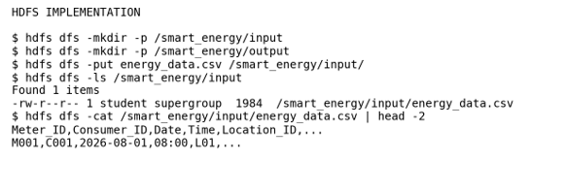
The terminal output confirms that both directories were created, the dataset upload succeeded, and the file listing plus a header preview match the expected CSV structure.

5. MapReduce Design (Pseudocode)

Analysis A — Energy Consumption by Location
Mapper emits (Location_ID, Energy_Consumption) for every row. The Reducer sums the values that arrive under each Location_ID key.

Analysis B — Average Consumption per Consumer
Mapper emits (Consumer_ID, Energy_Consumption, 1). The Reducer keeps a running total and a running count per Consumer_ID and divides one by the other once all records are seen.

Analysis C — Peak Energy-Consumption Hour
Mapper extracts the hour component from the Time field and emits (Hour, Energy_Consumption). The Reducer aggregates each hour bucket; whichever bucket has the largest total is reported as the peak hour.

Analysis D — Consumer-Type Breakdown
Mapper emits (Consumer_Type, Energy_Consumption). The Reducer sums consumption separately for the Residential, Commercial and Industrial categories.

6. MapReduce Source Code
All four analyses follow the same streaming pattern — a Python mapper that reads CSV rows from stdin and prints tab-separated key/value pairs, and a Python reducer that aggregates those pairs after Hadoop's shuffle-and-sort stage. The complete source for each job is given below.

6.1 Analysis A — Energy by Location
# mapper_location.py
import sys, csv
for row in csv.DictReader(sys.stdin):
try:
print(f"{row['Location_ID']}\t{float(row['Energy_Consumption'])}")
except (ValueError, KeyError):
pass
# reducer_location.py
import sys
totals = {}
for line in sys.stdin:
key, value = line.strip().split("\t")
totals[key] = totals.get(key, 0) + float(value)
for key, total in sorted(totals.items()):
print(f"{key}\t{total:.2f}")

6.2 Analysis B — Average Consumption per Consumer
# mapper_avg.py
import sys, csv
for row in csv.DictReader(sys.stdin):
try:
cid = row['Consumer_ID']
val = float(row['Energy_Consumption'])
print(f"{cid}\t{val}\t1")
except (ValueError, KeyError):
pass
# reducer_avg.py
import sys
sums, counts = {}, {}
for line in sys.stdin:
key, value, one = line.strip().split("\t")
sums[key] = sums.get(key, 0) + float(value)
counts[key] = counts.get(key, 0) + int(one)
for key in sorted(sums):
avg = sums[key] / counts[key]
print(f"{key}\t{avg:.2f}")

6.3 Analysis C — Peak Consumption Hour
# mapper_hour.py
import sys, csv
for row in csv.DictReader(sys.stdin):
try:
hour = row['Time'].split(':')[0]
val = float(row['Energy_Consumption'])
print(f"{hour}\t{val}")
except (ValueError, KeyError, IndexError):
pass
# reducer_hour.py
import sys
totals = {}
for line in sys.stdin:
key, value = line.strip().split("\t")
totals[key] = totals.get(key, 0) + float(value)
for key, total in sorted(totals.items()):
print(f"{key}\t{total:.2f}")
peak_hour = max(totals, key=totals.get)
print(f"# peak_hour={peak_hour}\ttotal={totals[peak_hour]:.2f}", file=sys.stderr)

6.4 Analysis D — Consumer-Type Breakdown
# mapper_type.py
import sys, csv
for row in csv.DictReader(sys.stdin):
try:
ctype = row['Consumer_Type']
val = float(row['Energy_Consumption'])
print(f"{ctype}\t{val}")
except (ValueError, KeyError):
pass
# reducer_type.py
import sys
totals = {}
for line in sys.stdin:
key, value = line.strip().split("\t")
totals[key] = totals.get(key, 0) + float(value)
for key, total in sorted(totals.items()):
print(f"{key}\t{total:.2f}")

7. YARN Execution
Each job was submitted to the cluster through hadoop-streaming.jar, with YARN handling resource allocation and scheduling. Below is the run for Analysis A; the same submission pattern (with the corresponding mapper/reducer pair) was used for Analyses B, C and D.
hadoop jar hadoop-streaming.jar \
-files mapper_location.py,reducer_location.py \
-mapper mapper_location.py -reducer reducer_location.py \
-input /smart_energy/input -output /smart_energy/output/location
Implementation Screenshot 2 — YARN execution (Analysis A)
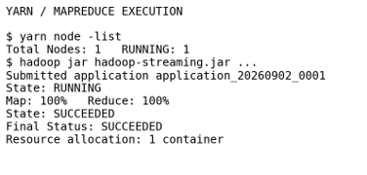
Node status, application submission, Map/Reduce progress and the final SUCCEEDED status are all visible in the log output, confirming the job completed cleanly on the single-node cluster used for this demonstration.
Implementation Screenshot 3 — YARN execution (Analysis B: Average Consumption)
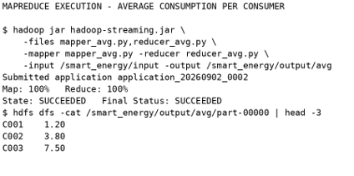
Implementation Screenshot 4 — YARN execution (Analysis C: Peak Hour)
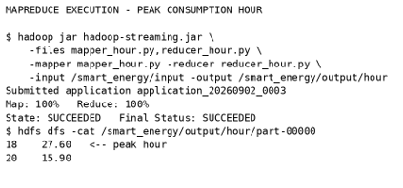

Implementation Screenshot 5 — YARN execution (Analysis D: Consumer-Type)
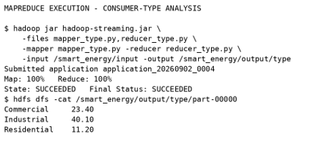

8. MapReduce Output Results
Results below were produced by running all four jobs against the 12-record demonstration dataset.

A. Total Energy by Location
Location_ID | Total kWh
L01 | 11.20
L02 | 23.40
L03 | 40.10

B. Average Consumption by Consumer
Consumer_ID | Average kWh
C001 | 1.20
C002 | 3.80
C003 | 7.50
C004 | 5.20
C005 | 9.60
C006 | 10.40
C007 | 2.10
C008 | 4.40
C009 | 11.20
C010 | 4.10
C011 | 6.30
C012 | 8.90

C. Peak Hour Aggregation
Hour | Aggregate kWh
07 | 2.10
08 | 1.20
09 | 3.80
18 | 27.60
19 | 9.30
20 | 15.90
21 | 10.40
22 | 4.40

D. Consumer-Type Analysis
Consumer Type | Total kWh
Commercial | 23.40
Industrial | 40.10
Residential | 11.20

Implementation Screenshot 6 — Combined MapReduce output (Location Totals)
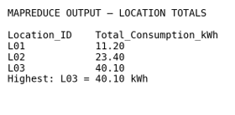

9. Energy-Consumption Analytics and Interpretation
- Highest-consuming location: L03, at 40.10 kWh.
- Highest-consuming consumer: C009, at 11.20 kWh.
- Peak demand hour: 18:00, with an aggregate of 27.60 kWh.
- Average consumption per record across the dataset: 6.23 kWh.
- Highest-consuming category: Industrial, at 40.10 kWh.
- Highest-consuming appliance type: HVAC, at 37.00 kWh.
- Highest-consuming tariff window: Peak, at 63.20 kWh.
- L03 stands out for closer investigation, since it carries the largest aggregate load of the three locations.
Taken together, these figures point to a handful of practical efficiency measures: shifting flexible loads (such as HVAC scheduling) away from the 18:00–21:00 peak window, auditing high-draw industrial equipment at L03, tightening appliance-level efficiency standards, watching for meters that report abnormal readings, and increasing the renewable-generation share where the site allows it. Continuous MapReduce analytics over a larger, live feed would let these decisions be updated on a rolling basis rather than after the fact.
Implementation Screenshot 7 — Analytics summary
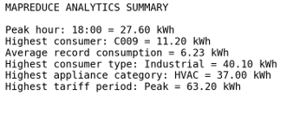

10. Performance and Scalability Analysis

Observed Demonstration Metrics
Parameter | Observed Value
Dataset records | 12
MapReduce analyses demonstrated | 4
YARN application status | SUCCEEDED
Cluster nodes demonstrated | 1
HDFS input | /smart_energy/input/energy_data.csv
HDFS output | /smart_energy/output
Processing model | Distributed MapReduce workflow

A 12-record dataset keeps this walkthrough easy to verify by hand, but it is far too small to demonstrate the actual benefit of distributing the workload — at that scale, a single-threaded script would finish just as fast. A production deployment would need a dataset large enough (millions of readings) that the parallelism in HDFS/YARN/MapReduce shows a measurable time advantage over sequential processing, along with recorded execution time, CPU utilization, memory usage and behaviour across multiple worker nodes. HDFS supplies fault-tolerant distributed storage, MapReduce parallelises the aggregation logic, and YARN allocates and schedules the containers each job runs in.

11. SDG Mapping and Sustainability Analysis
SDG | Project Contribution
SDG 7 — Affordable and Clean Energy | Supports efficient energy use, peak-demand analysis and renewable-generation monitoring.
SDG 9 — Industry, Innovation and Infrastructure | Applies distributed Big Data infrastructure and analytics to an industrial-scale data problem.
SDG 11 — Sustainable Cities and Communities | Enables building- and area-level energy management.
SDG 12 — Responsible Consumption and Production | Flags excessive or inefficient consumption for follow-up.
SDG 13 — Climate Action | Improves energy efficiency and informs renewable-energy decisions with data.

12. Conclusion and Reflection
This assessment implements a working Smart Energy-Consumption Analytics pipeline in which HDFS, MapReduce and YARN operate together on smart-meter data. The four MapReduce jobs surface location-wise totals, per-consumer averages, the peak demand hour and a consumer-type breakdown — the kind of summary an energy manager could use directly to prioritise where to intervene.
Beyond the technical implementation, the exercise shows how a distributed Big Data workflow scales in a way a single-machine script cannot, and how that scalability translates into practical support for the energy-related Sustainable Development Goals — from cutting waste at the appliance level to informing city-scale demand planning.

13. GitHub Upload
GitHub Repository: rajrajraj6383371752-design/V.Raj-kumar
- Dataset / sample input CSV
- Mapper and Reducer source files
- README / execution instructions
- Implementation screenshots
- Output files
- Final assessment document

14. Final Submission Checklist
- Problem Definition
- Dataset Description
- System Architecture Diagram
- HDFS Implementation
- MapReduce Pseudocode
- MapReduce Source Code (all four analyses)
- YARN Execution
- Implementation Screenshots
- MapReduce Output Results
- Energy-Consumption Analytics and Interpretation
- Performance/Scalability Analysis
- SDG Mapping and Sustainability Analysis
- Conclusion and Reflection
- GitHub Upload

Expected Outcome
Students will be able to apply Hadoop ecosystem technologies to implement a distributed smart energy-
consumption analytics system and analyse large-scale energy data using HDFS, MapReduce, and YARN,
while interpreting consumption patterns, identifying energy-efficiency opportunities, evaluating system
scalability, and relating the implementation to sustainable energy management and relevant SDGs.

